**­**

Abstract

This document outlines the approval request for conducting a comprehensive assessment of network and data centers to modernize and optimize the infrastructure for future needs.

Project Approval Request

IT Network & Data Center Design Modernization

Table of Contents

Project Details 3

Benefits & Impact Analysis 4

Risk Analysis 4

Contracting Approach 4

Estimated Budget 5

Approved Budget at my Board 5

High-level Timeline 5

Approval Decision 5

Approval Signoff 5

Revision History

|  |  |  |  |
| --- | --- | --- | --- |
| **Version** | **Change** | **By** | **Date of Change** |
| 1.1.2 | Initial version | Majd Alkhadraa | 24/Aug/2025 |
| 1.2.1 | Reviewed | Tammam Zakkar | 25/Aug/2025 |
| 1.2.4 | Reviewed & approved | Amr Marei | 26/Aug/2025 |
| 1.2.5 | Changing initial spend from Capex to Opex | Tammam Zakkar | 07/Oct/2025 |
| 1.2.5 | Reviewed & approved | Amr Marei | 07/Oct/2025 |

### Project Details

|  |  |
| --- | --- |
| Project Name | IT Network & Data Center Design Modernization |
| Program Name | REV - Digital Transformation Program |
| Project Duration | 3 Months |
| Expected Start Date | Sep – 2025 |
| Background/Problem  Statement | **Background:**   * Limited redundancy and failover mechanisms. * Single points of failure in network paths, power supplies, & cooling systems. * Outdated and fully loaded network switches, and routers. * Outdated servers. * Outdated power systems.   **Problem Statement:**   * The environment struggles to support growing data volumes and evolving digital business needs. *(Att #3)* * There is a S2.7 million budget for Neo-BAU for period (2025-2028). Expanding the lifespan of IT Infrastructure design to 10 years (at least) would increase this budget to around SAR4 million. * Current design may not accommodate future growth in user base, data volume, or new services. *(Att #4)* * Outdated power systems lead to energy inefficiencies and higher operational expenses. |
| UTEC Digital Transformation Objectives | 1. **Technologies**: Establish a robust 3x3 technology framework encompassing Enterprise Technology, Shop-floor Technology, and Facility Technology, each operating across Automation, Connectivity, and Intelligence to enable smarter, more efficient operations. 2. **Industry 4.0**: Integrate advanced manufacturing systems, including Manufacturing Execution Systems (MES) and the Industrial Internet of Things (IoT), to enable real-time monitoring, predictive maintenance, and seamless supply chain integration. 3. **Sustainability**: Embed Environmental, Social, and Governance (ESG) principles to minimize the carbon footprint, optimize resource efficiency, and align with global environmental goals. Enhance compliance with Health, Safety, and Environment (HSE) and Governance, Risk, and Compliance (GRC) frameworks. 4. **Artificial Intelligence:** Leverage AI and ML to enhance decision making, automate complex processes, and drive predictive and prescriptive analytics across operations. Enable intelligent systems that continuously learn and adapt to improve quality, efficiency, and customer responsiveness. 5. **Organization Development**: Cultivate a culture of innovation, collaboration, and empowerment through leadership alignment, strategic workforce development, and access to cutting-edge tools. |
| Project Objectives | 1. Evaluate network design, components, resilience, and security and recommend upgrades. 2. Assess all data center components through inspections and document review. 3. Identify aging equipment and gaps vs. standards. 4. Optimize space, power, and cooling for efficiency and future needs. 5. Propose UpToDate infrastructure design, roadmap, and cost estimates. 6. Develop network design for the new warehouse. |
| In Scope | 1. Core, distribution, and access layer devices (switches, routers and firewalls). 2. All data-centers include racks, cabling, power, and cooling systems. 3. UPS systems, backup generators, and power distribution. 4. All physical servers. 5. Storage (SAN/NAS), utilization, and redundancy. 6. Electrical, mechanical, and security infrastructure. 7. CCTV systems. 8. Access control systems. |
| Out of Scope | 1. Real time monitoring or management solutions. 2. Other corporate facilities beyond data centers. 3. Public or hybrid cloud platforms. |
| Priority: (Strategic / High /Medium) | Strategic |

### Benefits & Impact Analysis

|  |  |
| --- | --- |
| Operational & Process Benefits | * Standardizes operations and improves documentation. * Identifies inefficiencies and streamlines troubleshooting. * Integrate IT and OT. * Findings may require changes to daily maintenance procedures, escalation paths, or update cycles. * Understanding how power, cooling, and physical layout may impact IT performance and energy efficiency. |
| Financial Impact | * Provides visibility to split and time-phase the project for controlled execution. * Supports smarter and prioritized IT investments. * Enables the possibility of securing funds or incentives from governmental authorities. |
| Digital & Strategic Alignment | * Provides a roadmap and scalable architecture for future technology infrastructure. * Assesses readiness for AI, and smart infrastructure. * Supports sustainability goals and long-term strategy alignment. |

### Risk Analysis

|  |  |  |  |  |  |
| --- | --- | --- | --- | --- | --- |
| **Risk Name** | **Risk Description** | **Risk Analysis** | **Likelihood** | **Impact** | **Response Plan** |
| Incomplete or Inaccurate Assessment | Missing data, or misinterpretation could result in gaps or incorrect findings. | Lack of complete documentation or limited physical/logical access could lead to gaps in findings. | Medium | Medium | * Selecting a reputable technology partner with successful track records in similar projects. * Validate findings against industry best practice. |

### Contracting Approach

### 

|  |  |
| --- | --- |
| Governance Alignment | * Ensure the study supports long-term strategy, sustainability goals, and multi-year IT planning. * Research established frameworks and standards such as ISO 27001, ITIL, TIA-942. *(Att #5)* |
| Market Research | * Review industry best practices and assess potential partners' capabilities in data center assessments. * Identify vendor capabilities in terms of scalability, security features, support services, and integration with existing infrastructure. * Evaluate potential partners’ (IT Builders, Starlink, Btech, NTTData and Kyndryl) capabilities, technologies, and cost ranges. *(Att# 2)* |
| Final Selection | * Choose Kyndryl as the preferred partner based on proven experience, quality and methodology. *(Att# 1)* * Preceding with Kyndryl and executing the solution will secure 50% discount between (SAR200K) * The SAR200K assessment (5% of the SAR 4M initiative) will enable improving the design as well as reducing the estimated budget. * Additionally, there is a possibility of obtaining funds that worth 50% of the original quote (other SAR200K) |
| Signing the Contract | * Secure the agreed-upon commercial terms and sign by Oct 2025, to start the project on schedule. |

### High-level Timeline

|  |  |
| --- | --- |
| **Start Date** | **End Date** |
| 20-Sep-2025 | 01-Dec-2025 |

*Attachment 1*

Vendor Evaluation Matrix:

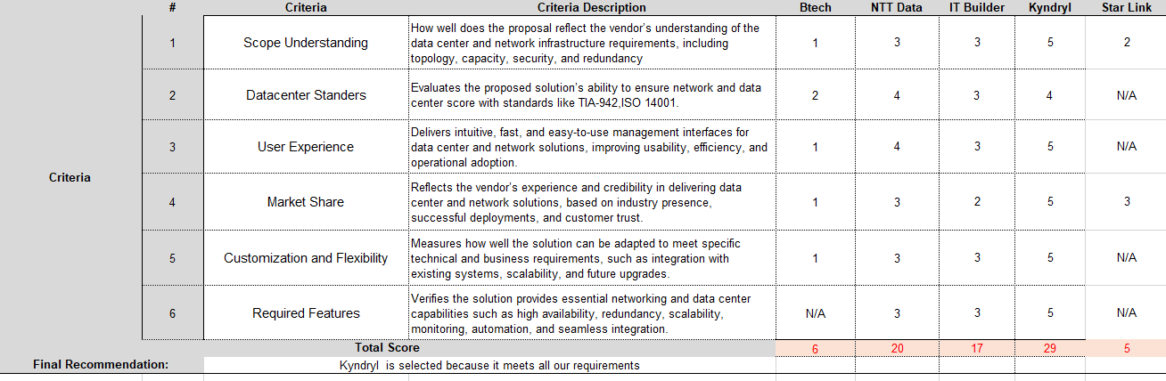

*Attachment 2*

Our initial study of Network and Data Center Bill of Materials (BOM):

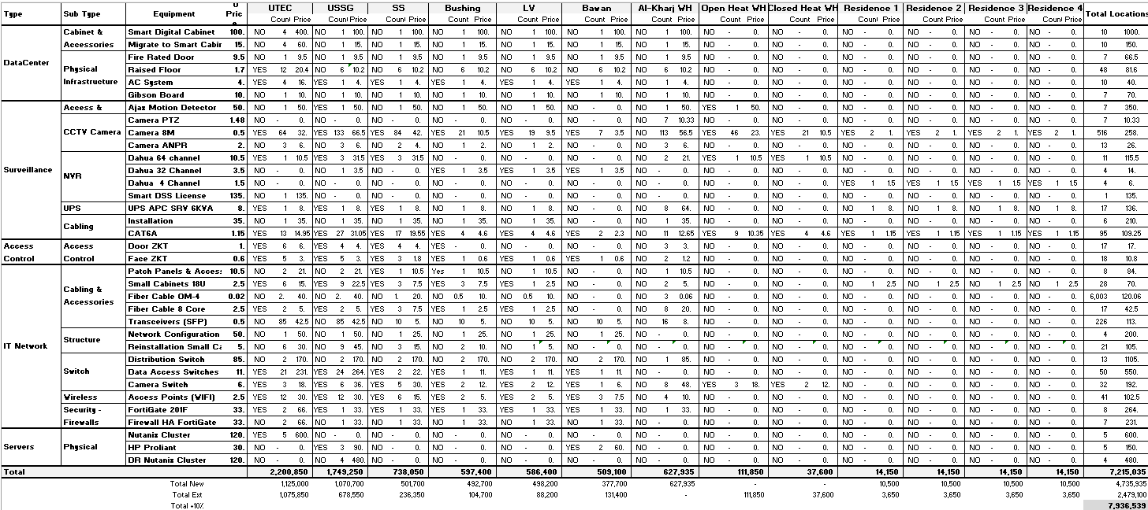

*Attachment 3*

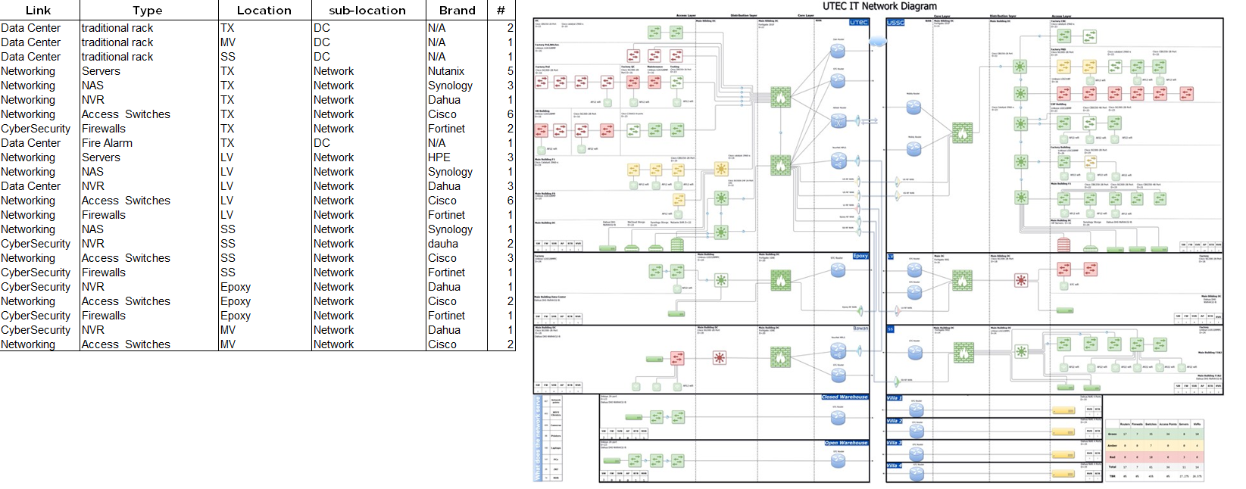Current IT equipment:

*Attachment 4*

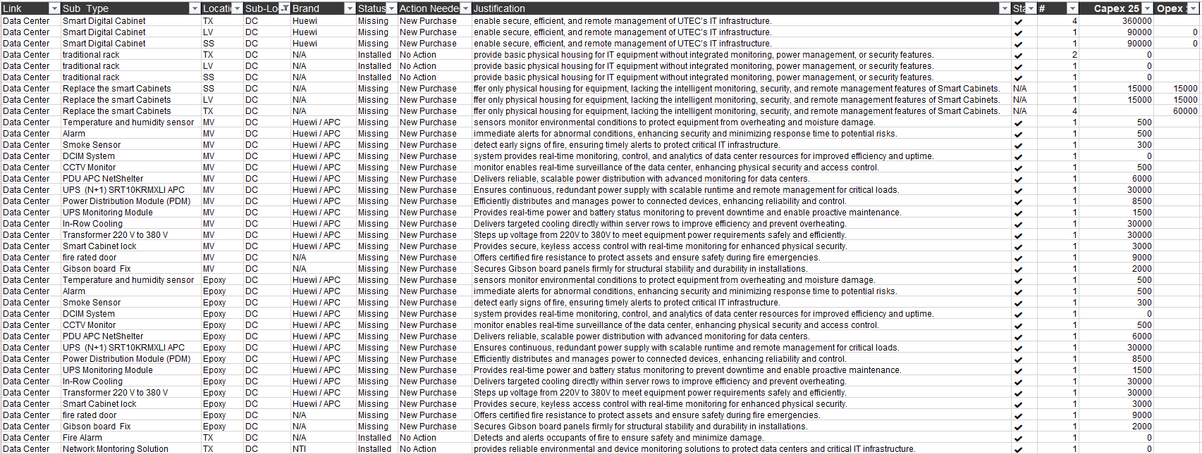Data Centers Items list::*Attachment 5*

ISO 14001/ TIA-942 Standers:

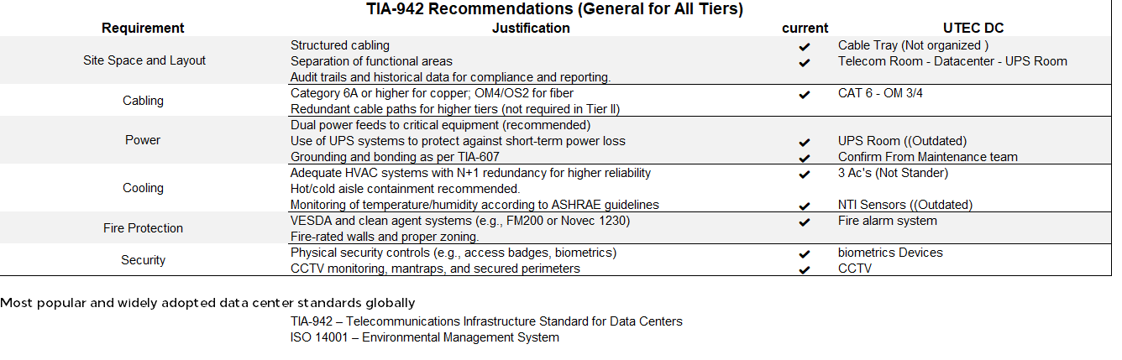

*Attachment 6*

Kyndryl Scope & Services

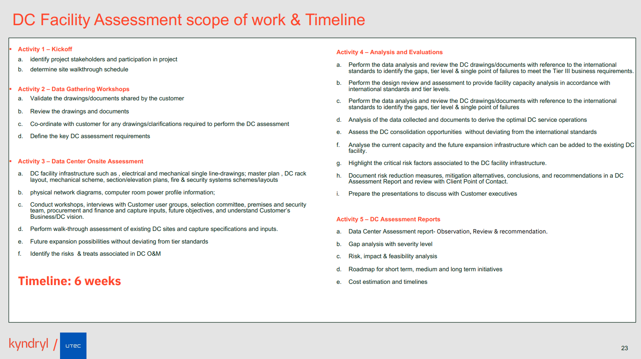

*Attachment 7*

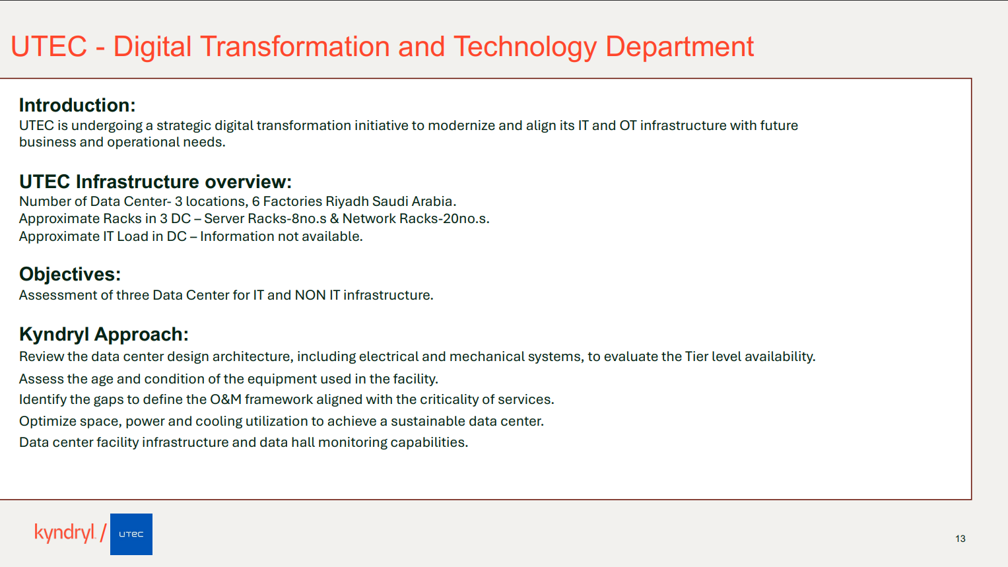Kyndryl Context and Key Objectives

*Attachment 8*

Kyndryl Commercial Overview

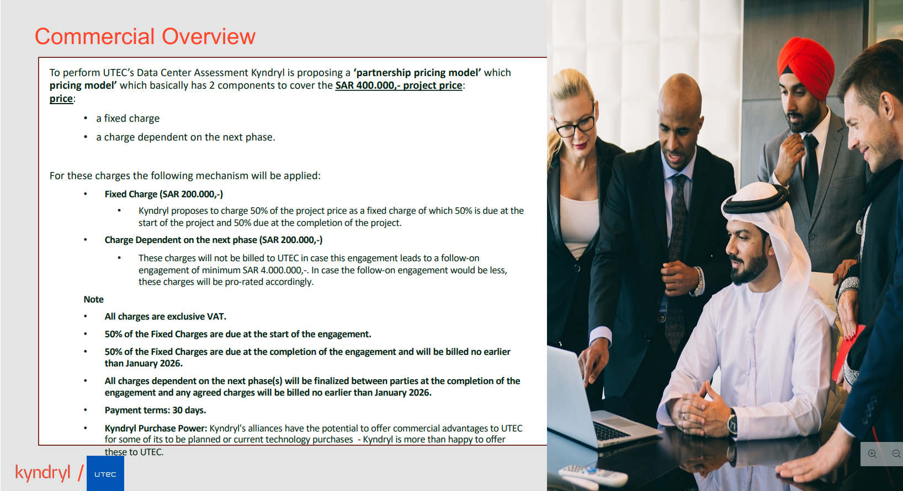

Attachment 9 - Team Profile



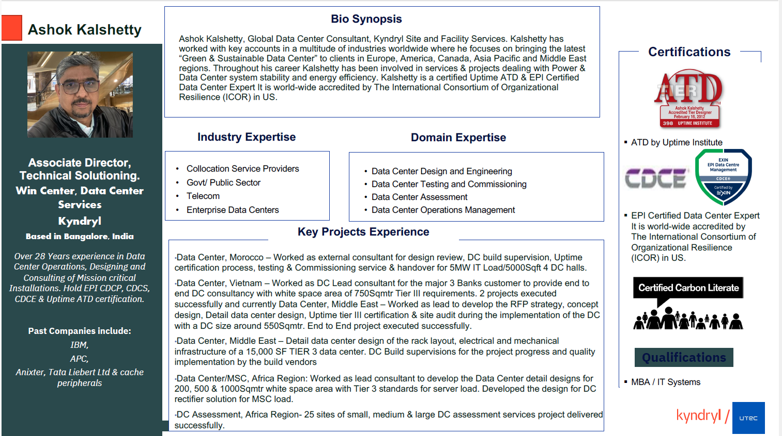

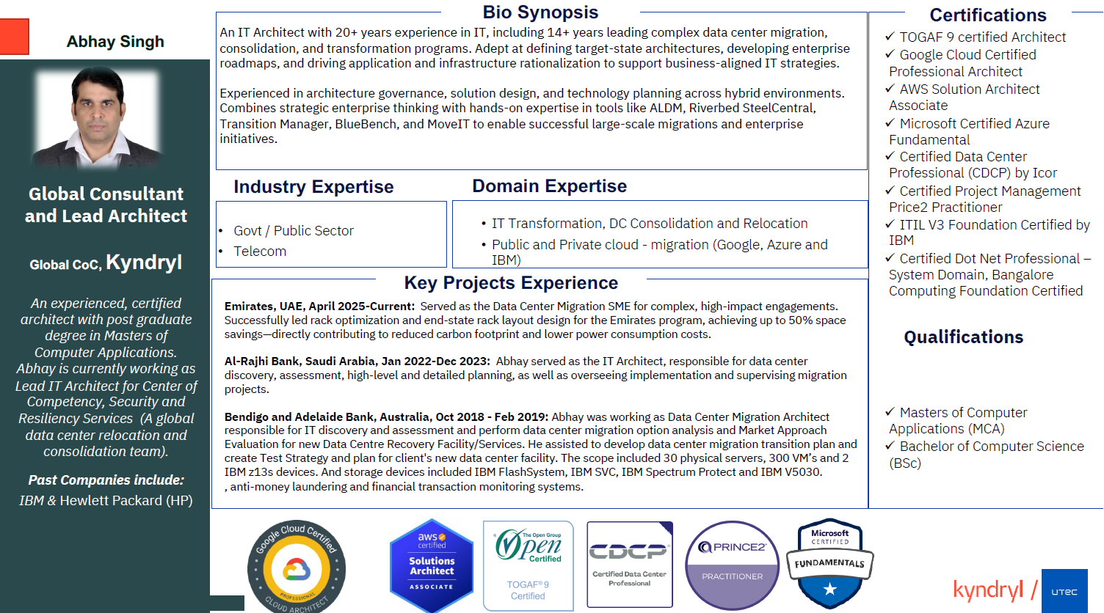

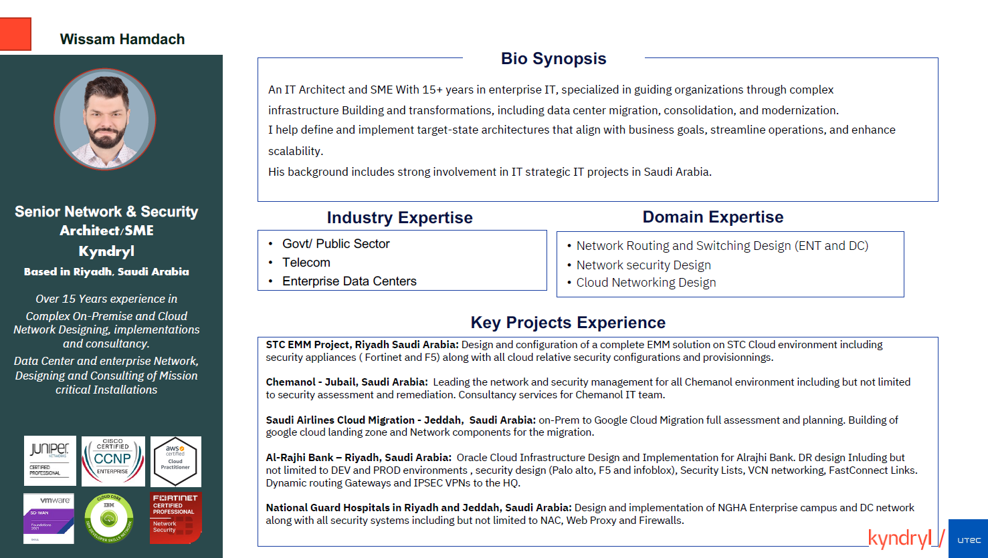

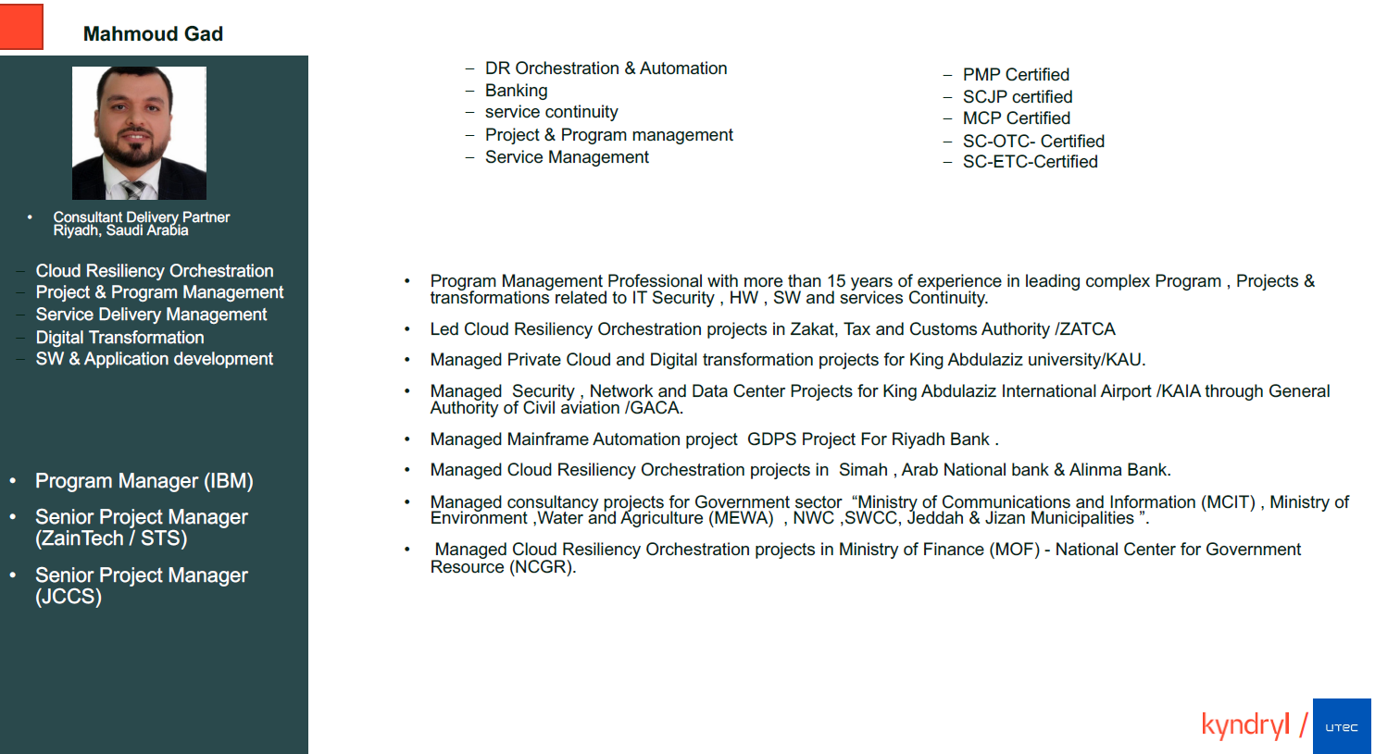

*Attachment 9*

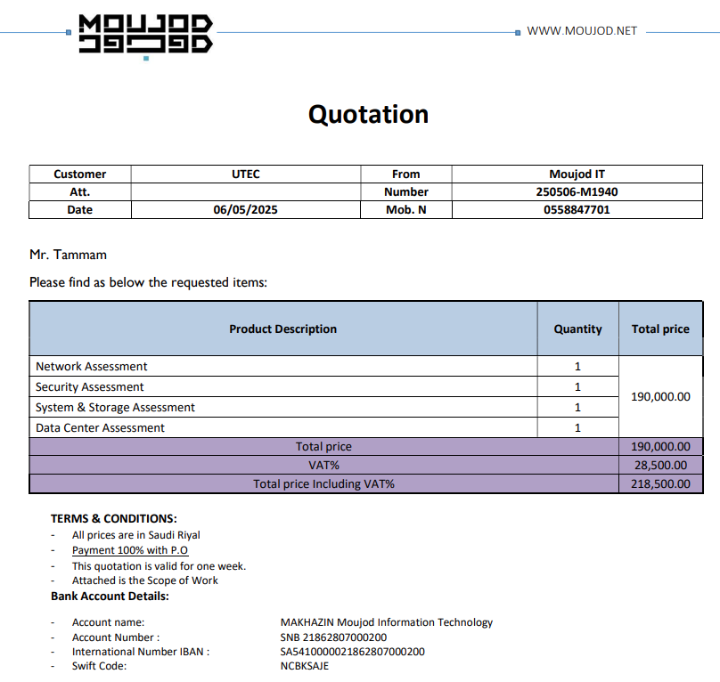NTTData Commercial Overview